**S2 lab si3g19**

**Phase Lead Compensation of an Inverted Pendulum**

**3.1 Position control**

$$Y=X+Lsin\left(θ\right)≈Y=X+Lθ$$

X position represented by VX

VY=VX+aVθ

* 1. **Proportional control**

5. Negative feedback

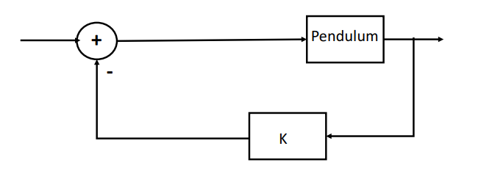

pendulum = tf(-49.05,[1,0,-49.05])

* K=0

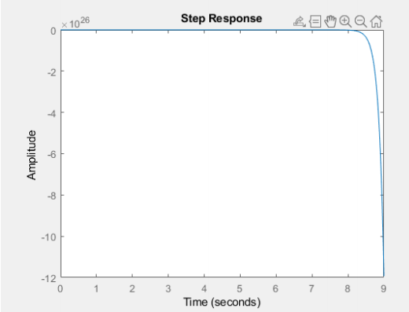

* K=1

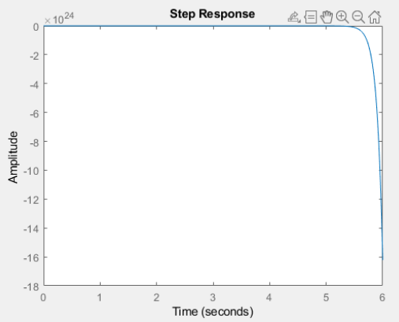

* System is unstable
* K=2

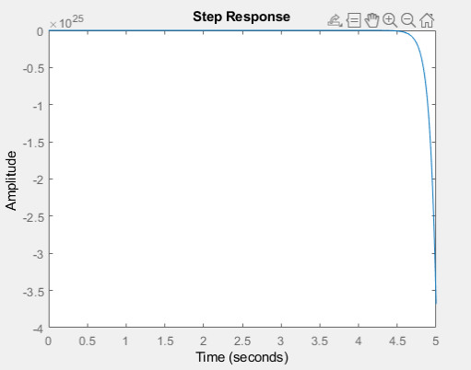

* K=10

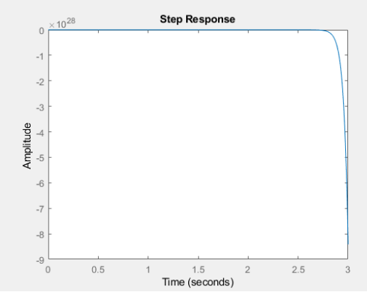

6. Positive feedback

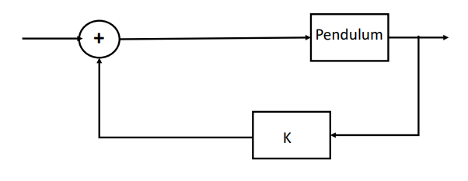

* K=0

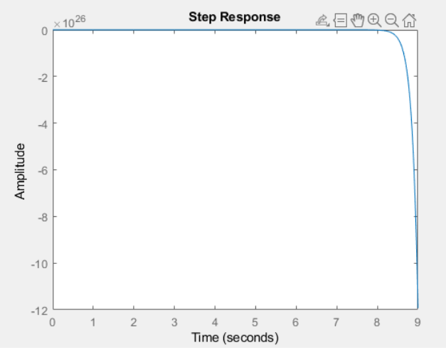

* K=1

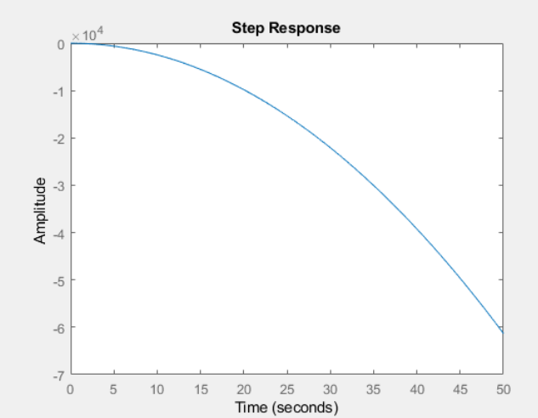

* K=2

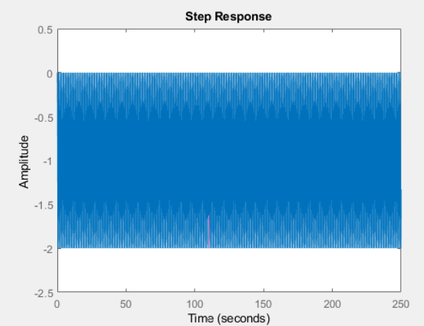

* K=10

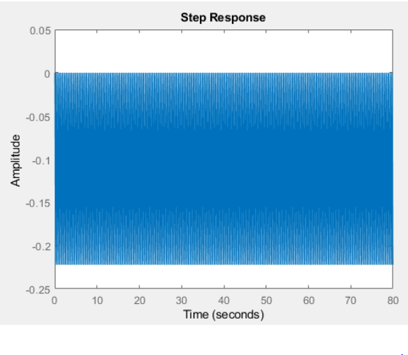

🡪 System becomes more stable, as k increases, the system no longer tends towards ±∞

7.

Positive feedback 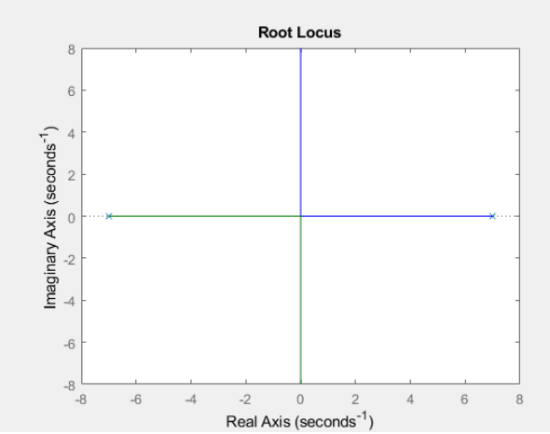

8.

* System is unstable
* Not all roots are stable
* Blue pole becomes more unstable
* Green pole becomes more stable

Negative feedback

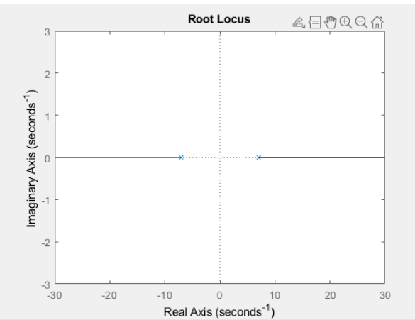

* System becomes (marginally) stable
* Both poles move towards stable/unstable: marginal stability to ±∞

9. Compare the behaviour qualitatively for different values of the gain. Is it consistent with the root-locus predictions?

As gain increases, pendulum accelerates increasingly to the side the pendulum leans.

Large gain: pendulum becomes erratic and unstable.

Corresponding to root loci, showing as K increases 🡪 system= unstable

* 1. **Lead compensation**

$$H\left(s\right)= \frac{1+cτs}{1+τs}$$

Place zero of compensator. Directly cancel stable pole of plant, choosing

$$ω= \frac{1}{cτ}$$

Use ‘high’ value of c, e.g. c=10

Use compensator of the form

H1(s)=

10.

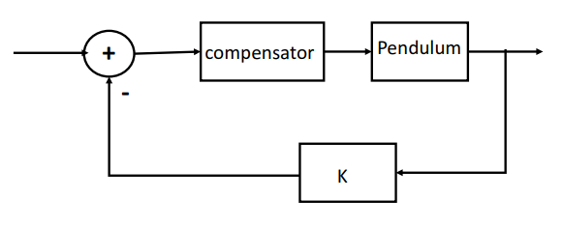

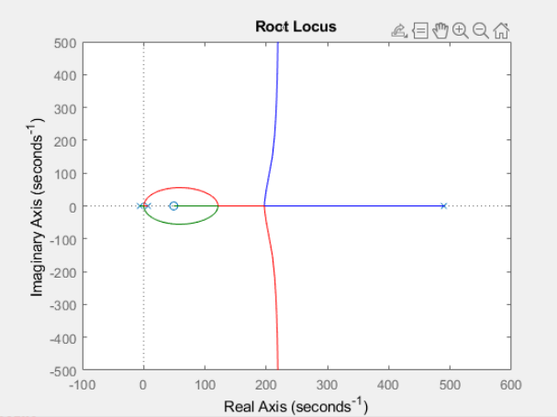

* System is initially unstable
* System remains unstable
* 2 poles are marginally stable but become unstable

11.

compensator2 = tf([0,0.1,1],[0,0.01,1])

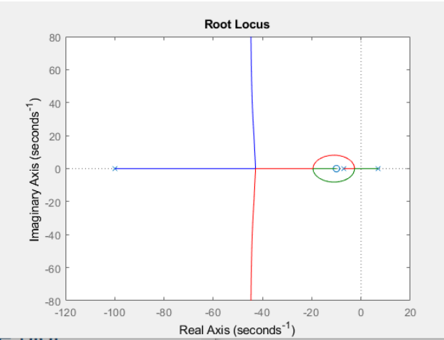

* 2 poles circle 1 root, ending at green point
* Another starts becoming stable, tends to ∞ (red)
* Blue pole starts becoming unstable, then tends to ∞

H1(s)=op-amp compensator circuit

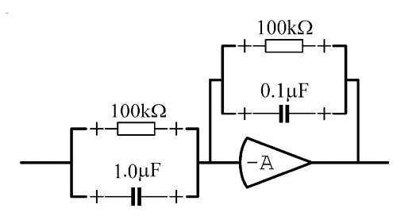

V0= output voltage

V1= input voltage

Zf= feedback impedance

Z1= impedance between V1 and summing junction

V0 / V1= ZF / Z1

For parallel circuit

R= resistor

C1= capacitor

1/ Z1 = (1/R) + C1s and 1/ Zf = (1/R) + Cfs

V0 / V1= - (1+R C1s)/ (1+R Cfs)

12.Explain using the root-locus plot why small values of the gain P2 do not lead to a stable closed loop.

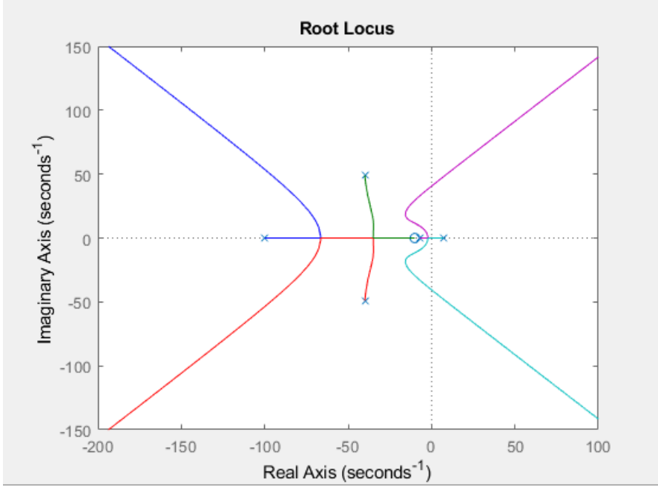

* Small gain, green pole= unstable
* $∴$ whole system = unstable
* System becomes stable after 1 pole crosses y axis
* All other poles are stable in the beginning
  1. **The neglected servo dynamics**

$G\left(s\right)= \frac{1}{0.00025s^{2}+0.02s+1}$

Natural frequency: $ω=10Hz$

Damping ratio $ζ=0.7$

13.

Upper limit: 8.7965

Lower limit: 0.9915

When gain > upper limit, pendulum becomes unstable and fails to balance

14.

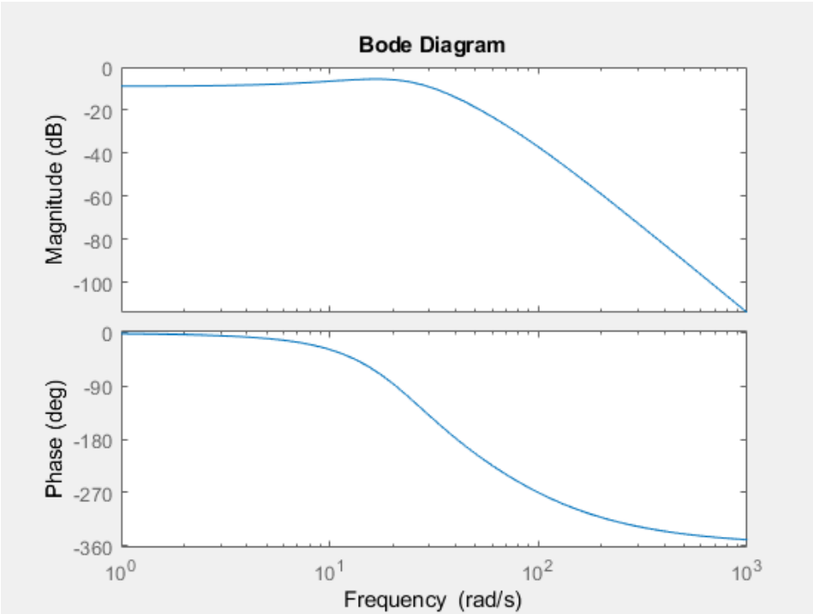

GM

Gain k:

(max) Gain margin: 8.83db

Phase margin: 344 degrees (?)

15.

Tapping the weight: system responds more aggressively to tapping

Makes small sudden changes before adjusting

16.

Moving the weight to the bottom of the rod causes the system to vibrate a lot and moves very quickly to adjust to the tap.